**Project Design Phase-II**

**Data Flow Diagram & User Stories**

|  |  |
| --- | --- |
| Date | 11 March 2025 |
| Team ID | ID 147626 |
| Project Name | **Cryptoverse: A Cryptocurrency Dashboard** |
| Maximum Marks | 4 Marks |

**Data Flow Diagrams:**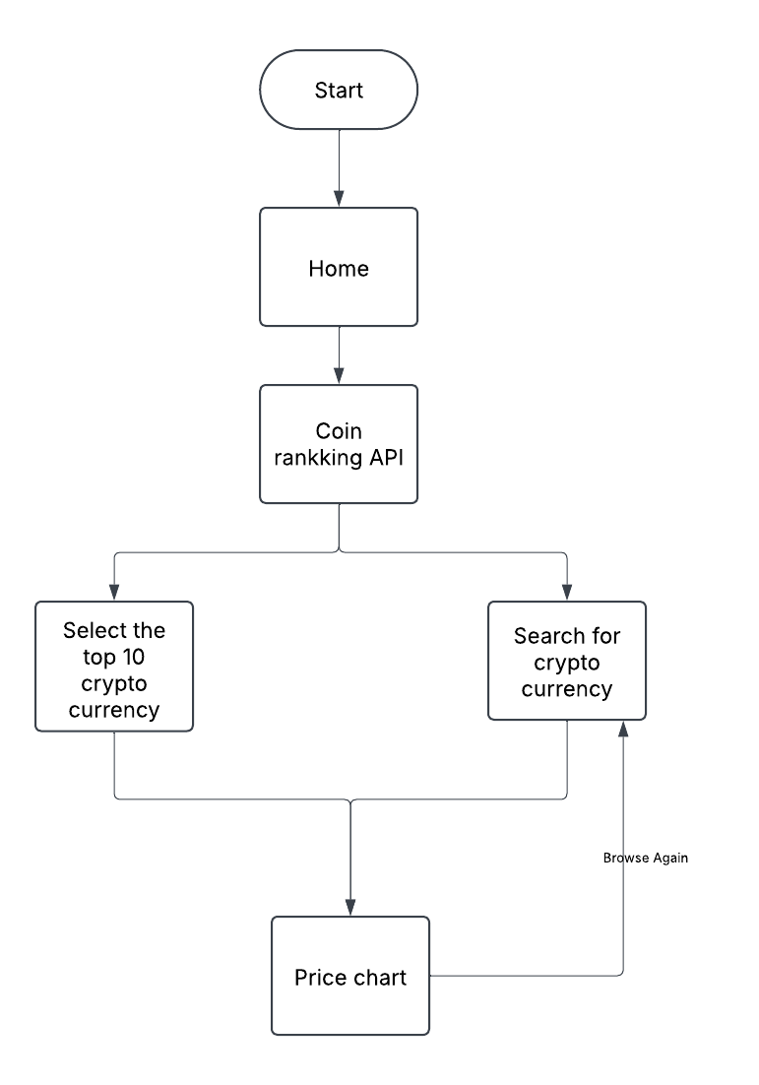A Data Flow Diagram (DFD) is a traditional visual representation of the information flows within a system. A neat and clear DFD can depict the right amount of the system requirement graphically. It shows how data enters and leaves the system, what changes the information, and where data is stored.

**User Stories**

Use the below template to list all the user stories for the product.

| **User Type** | **User Story Number** | **User Story / Task** | **Acceptance criteria** | **Priority** | **Release** |
| --- | --- | --- | --- | --- | --- |
| Customer  (Web user) | USN-1 | As a user, I can search for crypto currencies, Price chart or All crypto currencies | I can access my account / dashboard | High | Sprint-1 |
| Customer  (Web user) | USN-2 | As a user, I can view trending and top 10 crypto coins on home page | I can receive confirmation email & click confirm | High | Sprint-1 |
| Customer  (Web user) | USN-3 | As a user, I can buy, sell and View the Crypto currencies | I can register & access the dashboard with Facebook Login | Low | Sprint-2 |